Need that special report?
Buried in a time consuming manual process that requires 17 Excel spreadsheets and a pocket calculator?

Want to have all your reporting in one spot and be as easy as clicking a button or link on a webpage?

Griffin-Schruers does it all!

Our mission is to provide Business Process and Technology Consulting and Training with a focus on data mining and reporting tools (Cognos, Crystal Reports, etc.)
Training
(On-site, Over the Web, Formal Classes, Mentoring, Customizable)

Cognos 7.x, 8 and 10:
- Report Studio
- Query Studio
- Analysis Studio
- Impromptu
- Framework Manager
- Transformer
- PowerPlay
- Dimensional Reporting
- Special (Advanced) Topics
- Business Insight
- Business Insight Advanced
- Cognos Connection User
- Cognos Connection Administrator

Other:
- Crystal Reports
- MS Access

Roger Simon

President

Griffin-Schruers, incorporated .
P.O. Box 809, Waldron, AR 72958 ♦ 303-489-9420 (C) ♦ <call> (F)
www.g-si.com ♦ ras@g-si.com or ras@idcomm.com

Process and Technology Consulting
Business Intelligence ♦ Custom Programming and Reporting
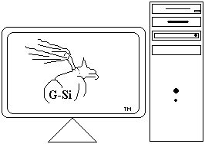



Consulting .

- Cognos 6.x, 7.x, Cognos 8, Cognos 10
- Crystal Reports 4.6 to present
- MS Access / MS Office

- Custom report writing
- Financial Reporting
- Requirement Gathering
- OLAP Cube building
- Modeling (Frameworks, Dictionaries, etc.)
- Data warehousing
- Project Management
- Upgrades
- System/environment assessment
- Tuning and Optimization
- Training / Mentoring
- Custom rapid application development
Roger Simon

President

Griffin-Schruers, incorporated .
P.O. Box 809, Waldron, AR 72958 ♦ 303-489-9420 (C) ♦ <call> (F)
www.g-si.com ♦ ras@g-si.com or ras@idcomm.com

Process and Technology Consulting
Business Intelligence ♦ Custom Programming and Reporting

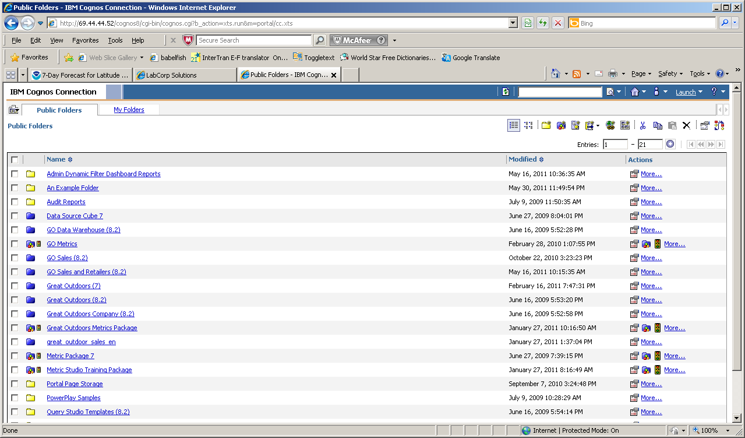
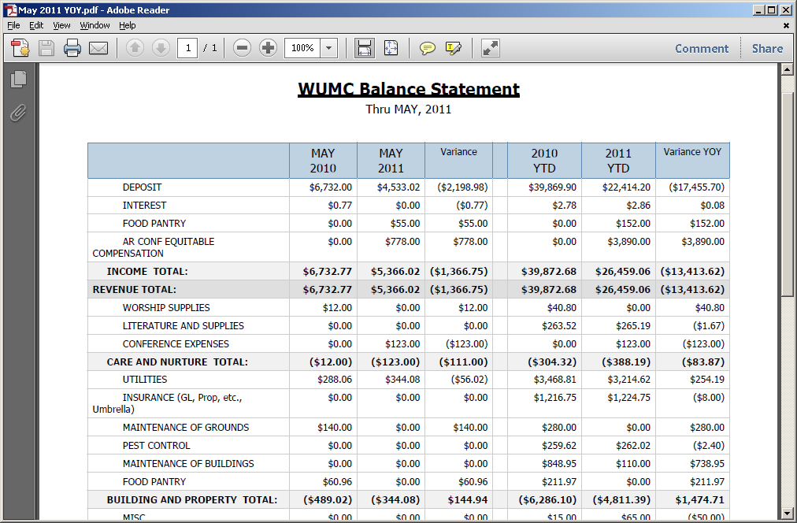
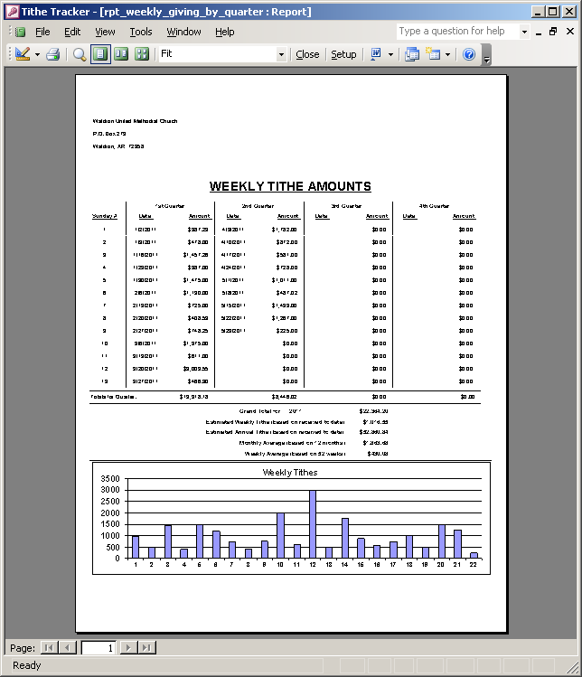
While not textbooks, our training classes include in-depth powerpoint slides that walk students through the steps of each application
Financial reporting and customized portals are a few of the things we can help with
Unique reporting needs drive our custom application development

