Let's Play
BCJSA – Soccer wishes to express our Thanks to the following companies who have made various donations, assisting our youth in enjoying the sport of Soccer.

Colorado Mortgage Network LLC
Griffin-Schruers, Inc.
Colorado Medical Waste Inc.
Wal-mart
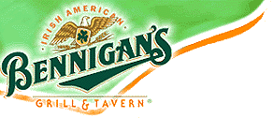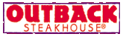

Soccer!
Note: Soccer Registration fees include: Club award, Team and Individual Picture, and Referee fees!
BCJSA
1947 South Wadsworth Blvd. #331
Lakewood CO, 80227



