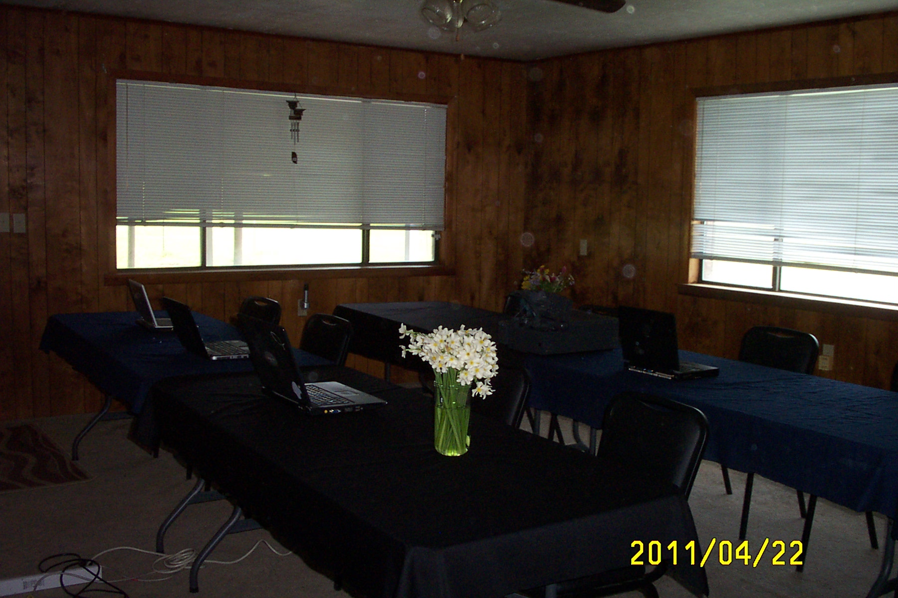

Training
Facilities

Instructor-led on-site software training in:

- Cognos8
- Cognos10
- Crystal Reports
- MS Access

We can also host your own custom class

bring your laptop and clip into our DSL

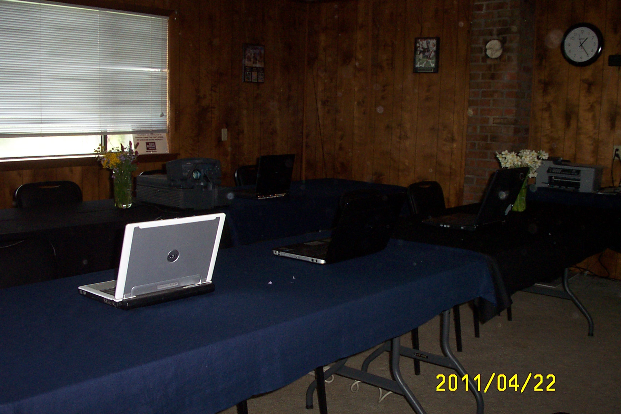

_Name_____________________
_Address Line 1_____________
_Address Line 2_____________
_City, State Zip______________

The Farm Conference and Training Center
P.O. Box 809
Waldron, AR 72958

The Farm

Conference and Training Center

Waldron, AR

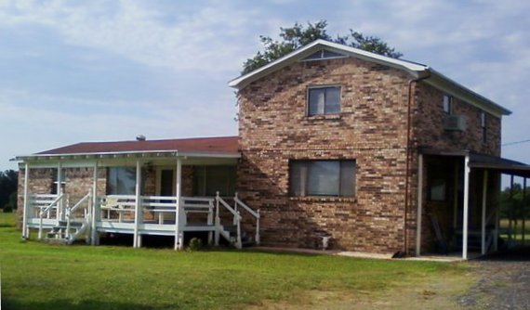

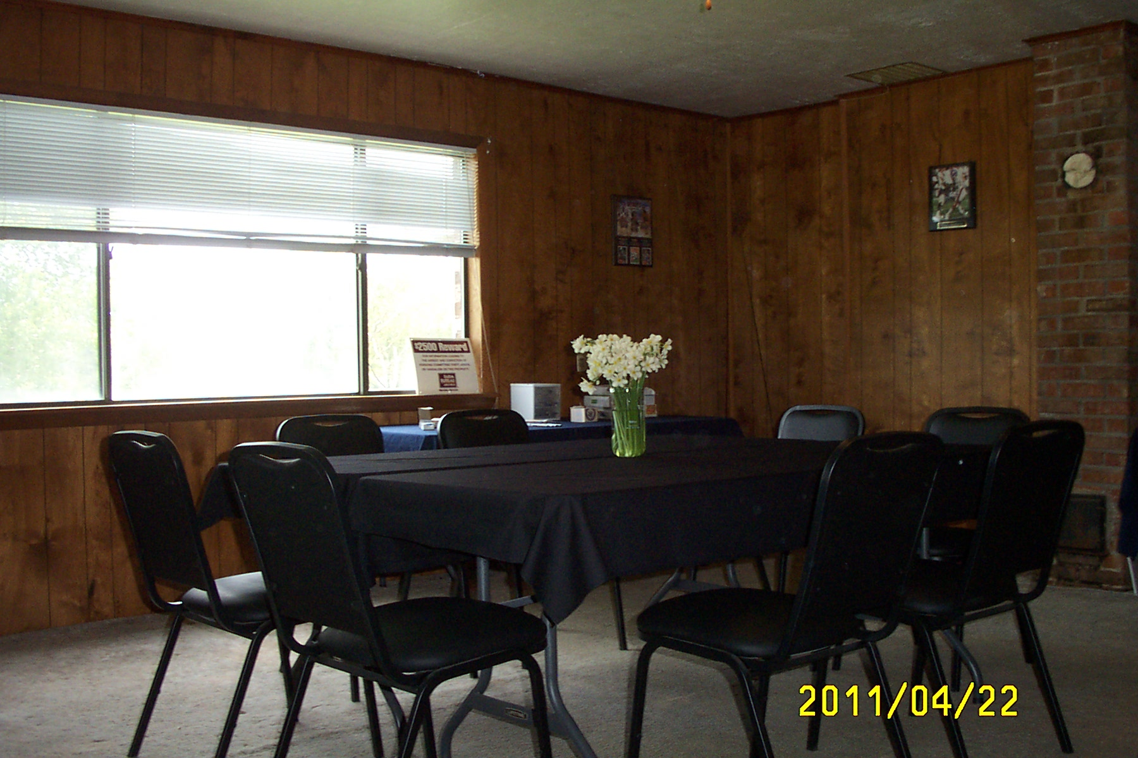

Waldron, AR
Eateries
Charbroiler
McDonald’s
Sonic
Lin’s Diner
Olde World Pizza
El Palenque
Pizza Hut
Waldron Oriental Market
La Casona

Lodging
Southern Nights
Coachman
Cypress Barn

Area Attractions
Scott County Theatre
(in Waldron)
Ouachita Mountains
Ouachita National Forest
Queen Wilhelmina State Park
Forrester Historical Site
Heavener Rune Stone
Lake Ouachita

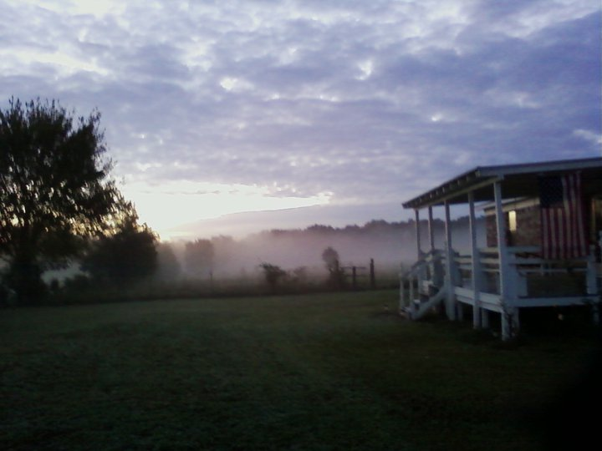



Meeting
And
Conference
Center
Facilities

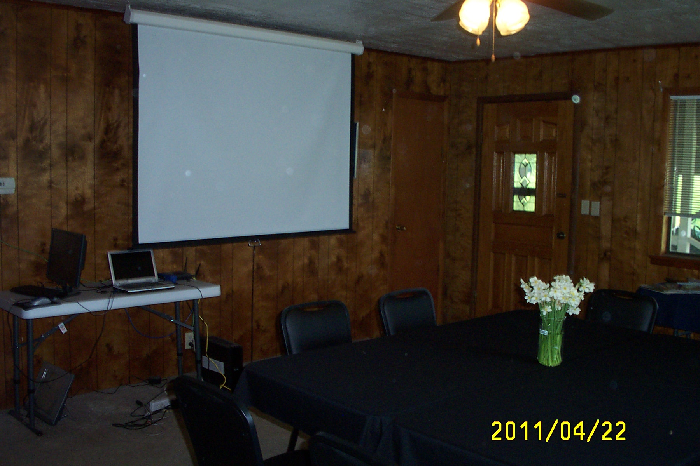

Hold your meeting for 2 – 14 persons in our comfortable, spacious meeting room

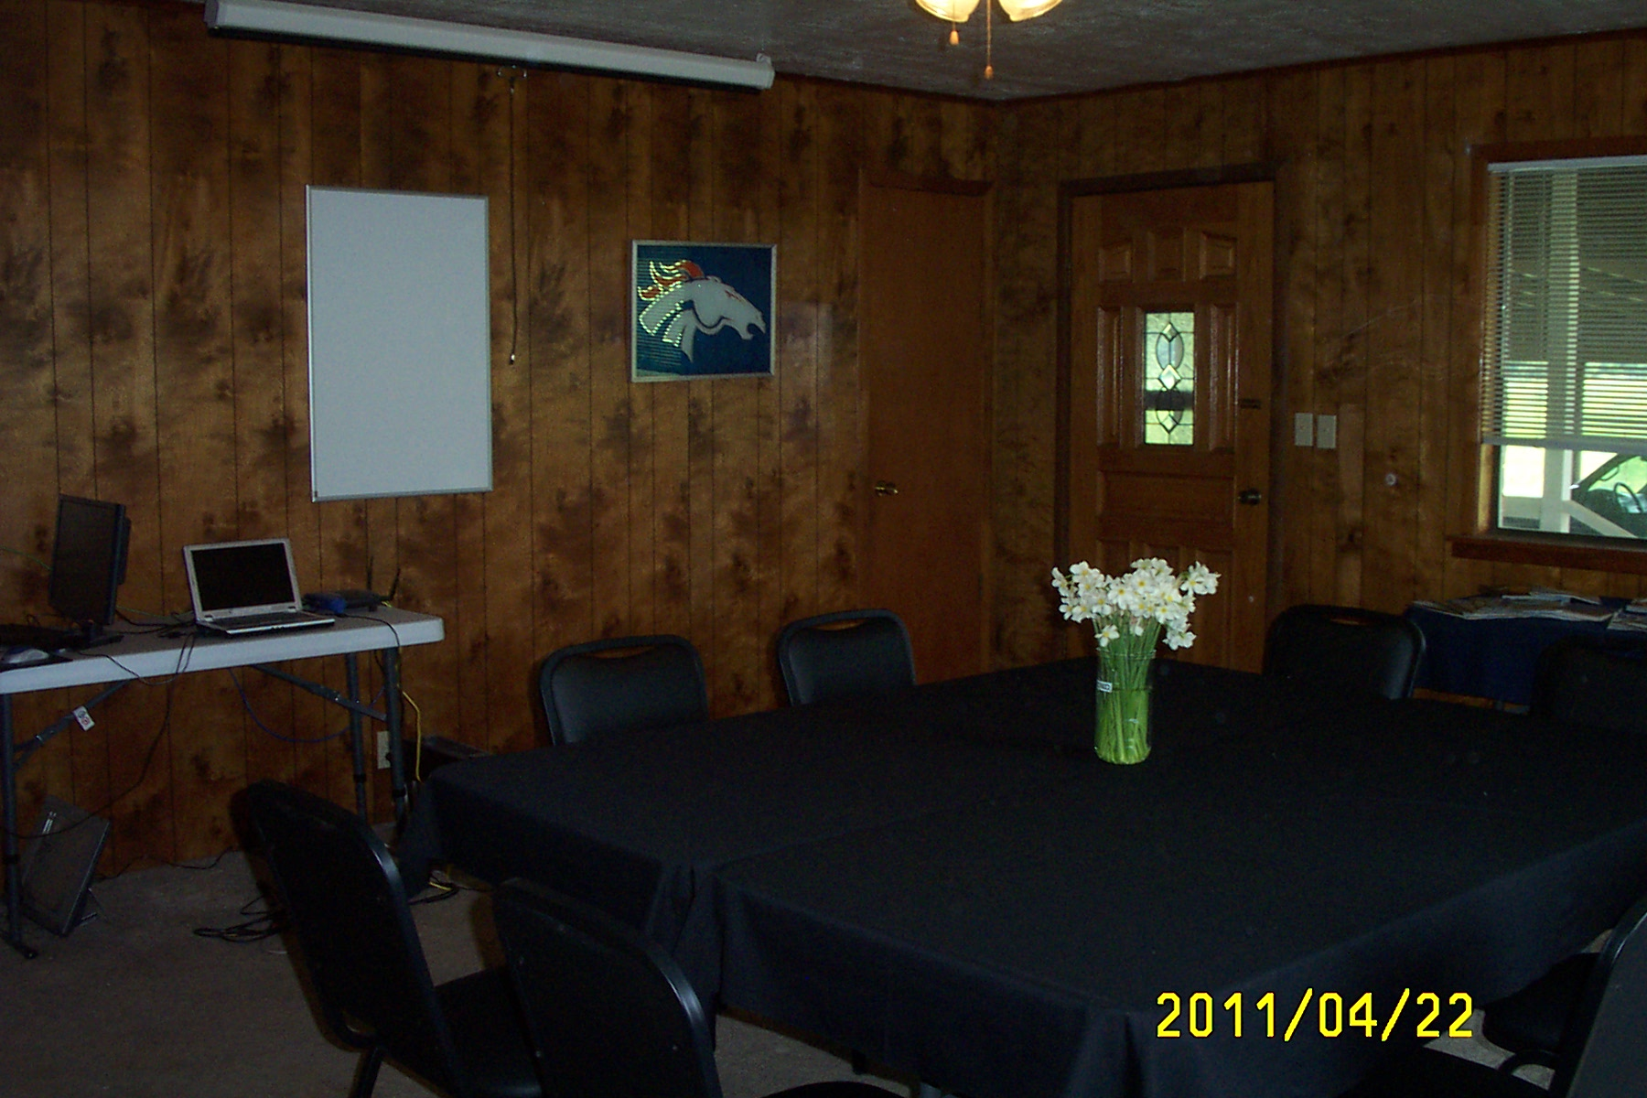

Scott County
Hiking
Camping
Fishing
Hunting

- On-site Pond at The Farm for fishing (bass, catfish, various brim)
- Bonfires
- Local Guides and trips available

