Directions to Waldron:

From Fort Smith, AR

Take US-71 south from Fort Smith to Waldron approximately 35 miles.
Turn left onto US-71 Business, 2.5 miles into the center of town.

Approximate miles: 50
Approximate driving time: 1 hr

From Tulsa, OK (TUL)
From Tulsa Airport, exit the airport only OK-11 going east.
Go 1.4 miles and bear left onto I-244 (Joplin).
Stay in the right lane 1.3 miles and exit onto US-169 southbound.
From US-169 (4.7 miles), take the Broken Arrow Expressway / Muskogee Turnpike ( OK-51 ) eastbound 39 miles to I-40.
Take I-40 eastbound to Roland, OK (exit #325).
Follow US-64 6.7 miles into downtown Fort Smith and take a right onto Towson (just at the end of Downtown; US-71 Bus).
South on Towson 4.5 miles. Right (south) onto US-71 approximately 35 miles.
Turn left onto US-71 Business, 2.5 miles into the center of town.

Approximate miles: 165
Approximate driving time: 2 hrs 45 min

From Little Rock, AR (LIT)

From Little Rock airport, take I-440 westbound.
Approx. 2.5 miles, merge left onto southbound I-30 (Texarkana / Hot Springs).
Take southbound I-30 27.4 miles to US-70 westbound, following the signs to Hot Springs.
At 18.7 miles, bear right onto the US-270 business cut-off (follow the sign for Mt. Ida).
Exit left 11.9 miles to US-270 (Mt. Ida).
Take US-270 westbound 64.4 miles to “Y” City.
Turn right onto US-71 (northbound) 14 miles.
Turn right onto 6th St (aka AR-80); 1 mile to center of town.

Approximate miles: 141
Approximate driving time: 2 hrs 30 min

From Oklahoma City, OK (OKC)

From the Oklahoma City airport, take I-44 westbound to I-240.
Take I-240 eastbound 16 miles and merge onto I-40 eastbound.
Take I-40 eastbound to Roland, OK (exit #325).
Follow US-64 6.7 miles into downtown Fort Smith and take a right onto Towson (just at the end of Downtown; US-71 Bus).
South on Towson 4.5 miles. Right (south) onto US-71 approximately 35 miles.
Turn left onto US-71 Business, 2.5 miles into the center of town.

Approximate miles: 234
Approximate driving time: 4 hrs

From Dallas, TX (DFW)

Exit the DFW airport onto International Parkway S (TX-97 Spur S), 1 mile.
Take TX-183 / TX-360 eastbound 11 miles to I-35.
Merge onto I-35 eastbound and go 5 miles to I-30.
Take I-30 eastbound to Texarkana, AR/TX approx. 167 miles.
Take exit #223B at Texarkana and go north on US 71.
Follow US-71 northbound approx. 130 miles.
Turn right onto 6th St (aka AR-80); 1 mile to center of town.

Approximate miles: 330
Approximate driving time: 5.5 hrs

Directions to the Training Center from the center of Waldron:

North on US-71 Business approx. 1 mile to City Lake Road (on the right)
Take a right on City Lake Road and go approx. 2.3 miles to Taff Line (on the right; Taff Lane is just before the Birdsview Cemetary).
Take a right onto Taff Lane and go .3 miles.
Turn right into the Training Center driveway.

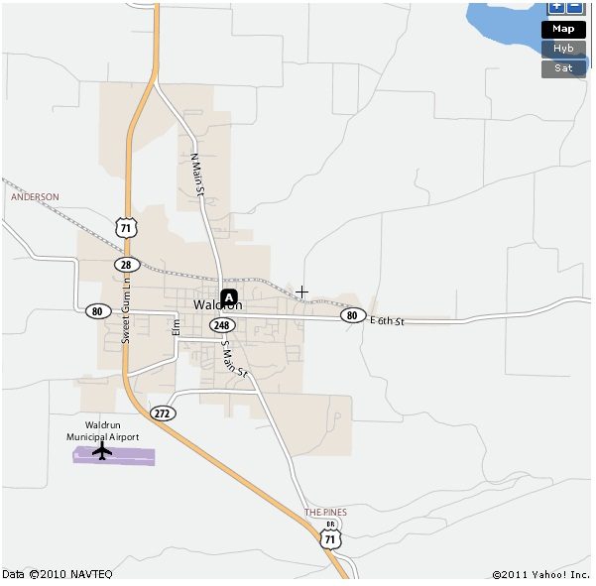
The Waldron Area:

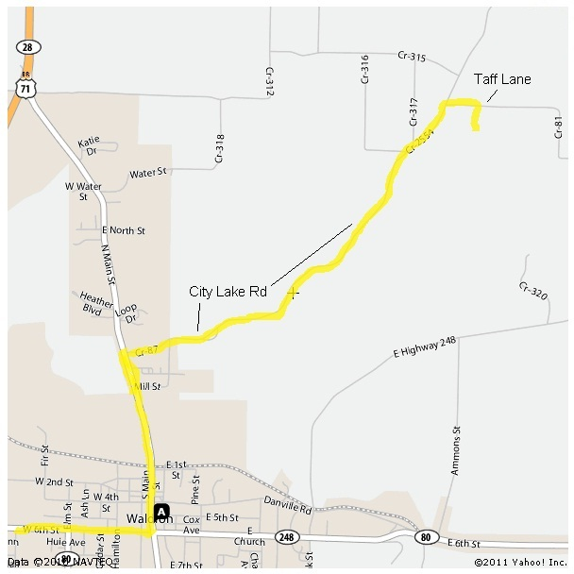
The Farm Conference
And Training Center:

Lodging:
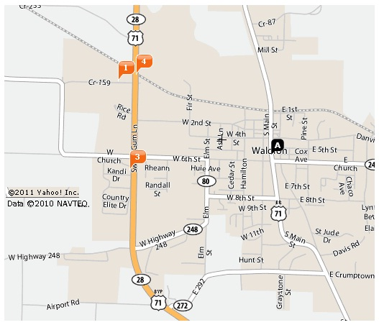

4. Cypress Barn Inn
636 Frankie Matthew Dr.
Waldron, AR 72958
479-637-3451
$38.41

3. Coachman’s Inn
89 US-71 Bypass N
Waldron, AR 72958
479-637-4157
$24.99 single
/ $44.99 double

1. Southern Nights
1622 Rice St.
Waldron, AR 72958
479-637-4851
$45.00

Other Lodging:

Mena (approx. 30 miles)

Fort Smith (approx. 50 miles)
Guest House
Homewood Suites
Holiday Inn Express

Dining / Food:

El Palenque (1) - Mexican
Pizza Hut (2) – Pizza/Italian
Old World Pizza (3) - Pizza
McDonald’s (4) – fast food
Charbroiler (5) – country cooking
Lin’s Diner (6) – Chinese menu/buffet
Sonic (7) – fast food
Judy’s Diner (8) – country cooking
Oriental Market (9) – asian grocery store
The Rock Café (10) – country cooking
Super Donut (11) – donuts, breakfast sandwiches, burritos
Scott County Theatre (12) – movie snacks (Fri, Sat, Sun only)
Dan’s Authentic Tex-Mex (13) – mexican
The Restaurant at Queen Wilhelmina State Park Resort (about ½ hour drive) – country cooking

Fort Smith: (1 hr drive north on US-71) hosts the usual array of dining places (Applebee’s, Chick-fil-A, Outback, La Huerta, Cheddars, Chili’s, Wendy’s, Burger King, Olive Garden, Red Lobster, etc.)

Greenwood: (45 min drive north on US-71) hosts a Vietnamese place, Imajerk 2 BBQ, Bulldog Diner, El Palenque, La Fiesta, McDonalds, Sonic, Taco Bell/KFC, Arby’s,

Mansfield: (20 min drive north on US-71) hosts a Subway and a Sonic.

Mena: (1/2 hour drive south on US-71) hosts a Chinese buffet, Wendy’s, Kentucky Fried Chicken, a barbeque place, etc.)
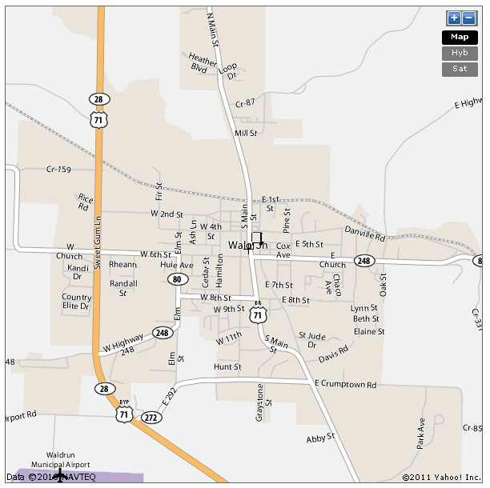

1
2
3
8
7
6
9

4
5
13

10
11
12

Area Attractions:

Scott County Theatre

Shows current, first run movies on Friday, Saturday and Sunday nights
Ticket office opens 7 pm; movie starts 7:30 pm. All tickets: $6

Queen Wilhelmina State Park

Take the scenic Talimena highway from Mena, AR to the top of the Quachita Mountains. Queen Wilhelmina State Park features hiking, RV camping, a restaurant and a resort (some rooms even have hot tubs!) with in a breath-taking outdoors atmosphere at the top of the mountains.

Mount Magazine State Park

North of Waldron off Highway 10, Mount Magazine is one of the prettiest places in the whole state. While the Queen Wilhelmina area is more mountainous overall, Mount Magazine is the highest point in the state of Arkansas. It also boasts a new, beautiful resort at the top with a fine restaurant.

